%%%%%%%%%%%%%%%

Competition Time

Maths Week in Le Chéile

17th – 21st October 2016

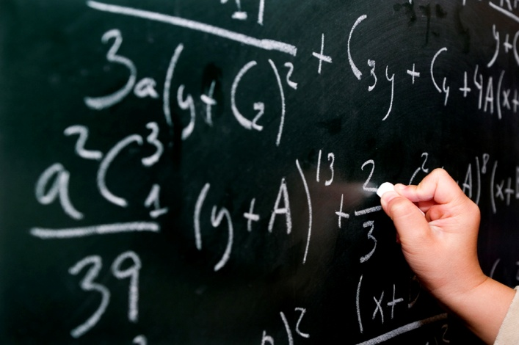
All classes are invited to enter a few in-school maths competitions to celebrate Maths Week 15.
Best Maths Door
Classes decorate the outside of their classroom doors with all things mathematical.
Anything goes. Be creative.
The class with the winning door will receive a certificate and a night off homework

Estimation competition
Children have to estimate how many cubes are in a see through container. This will be on display for all to see during the week.
Amount of cubes will be anounced on Friday over the intercom system.
%%%%%%%%%%%%%%%%%%%%%%%%%%
%%%%%%%%%%%%%%%%%%%%%%%%%%

You did Maths where? Competition

Due to the popularity of this competition last year
children are again encouraged to take a picture of themselves doing maths somewhere in the environment outside of school. The whackier the better. Entries in by Thursday 20th as I would like to announce the winner on Friday and put the entries on a display board in the corridor.

=+-=+-=+-=+-=+-=+-=+-=

Feel free to enter none, some or all of the above in-school competitions.
If anyone has any other good ideas that the school as a whole can participate in please let me know so we can all share them.

Happy Maths Week 2016

Monica

%%%%%%%%%%%%%%%%%%%%%%%%%%

